**BWERA SECONDARY SCHOOL**

**S.4 CHEMISTRY ACTIVITY OF INTEGRATION**

**TOPIC: CARBON IN LIFE**

**TIME: 1HR**

The government of Uganda has been championing the program of wealth creation all over the country especially in the lower villages. One of the activities in this program is fish farming where people are encouraged to dig fish ponds in valleys where they can stock fish. At the beginning of this project, the production of fish was so high. Two years later, fish started dying, the ponds developed funny smell. The water in the pond turned colour to green and then finally the whole water surface became covered with certain plants. People have failed what to do since they don’t know the cause of this problem. The farmers have now reported this concern to their local leaders.

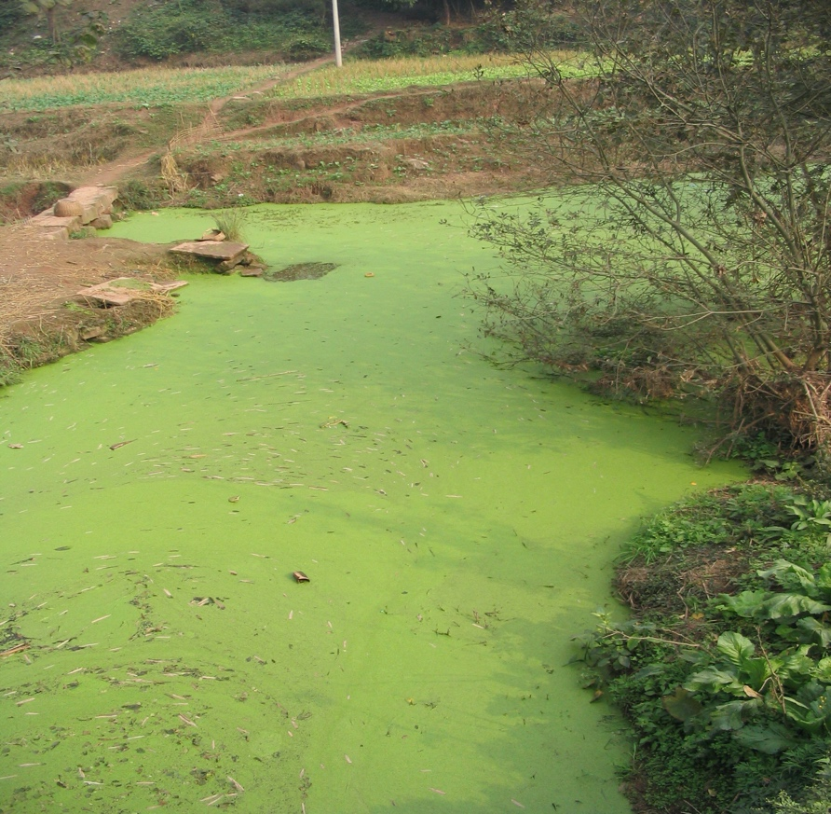

The local leaders have decided to organize a seminar on fish farming and invited all fish farmers to attend this seminar.

**Task**

You have been invited as a guest speaker during the seminar. Prepare a message you would deliver to the fish farmers.

***End***